101 102 103 104 105 106

LX5

Legend:
12 of CKC Tour Pro Aurora V6

301 302 401 402 303 304
7 of CKC Tour Pro Aurora V4

12 of CKC Tour Pro ZB19IP

4 of Chauvet Strike Array 2c

4 of Chauvet Strike Bolt 1c

107
108
109 110 111 112

LX4

18 of Chauvet Ovation Reve - E

8 of Chauvet Ovation Reve - F
Z

403 305 306 307 308 404
41 42

201 203

LX3

309 21
501 310 22
202
23 311
502
24 312

321 322

Z
31 51

Z Z
32 52 33

Z
53 34

503 504

LX2 LX1

204 205
206
207 208

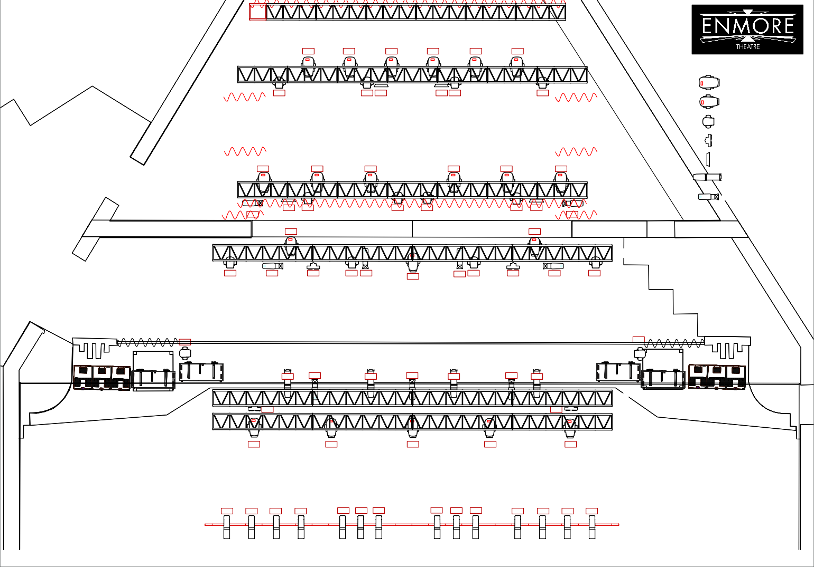
1 11 12 2
3 13 4
5 14 6
7 15 16 8

